**White Oak Farm Maple Syrup**

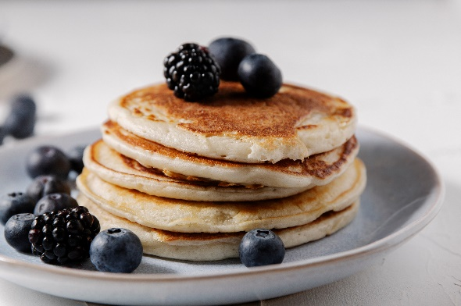

**Small Size - $20.00**

**Large Size - $33.00**

**White Oak Farm Honey**

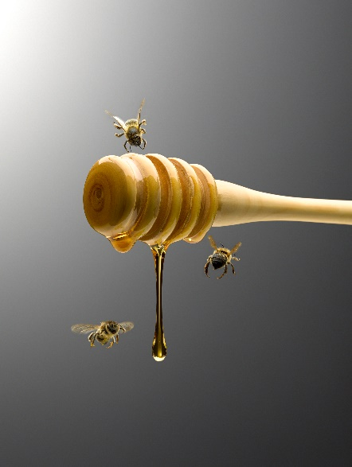

**$20.00**